PCAP
Upgraded Biannual forms + The New Zero – Month Biannual

Hi Supervisors and Mentors,
Changes to your Biannuals are here. After April 1, 2016, you’ll be able to see some modifications to the standard biannual forms, and when the time comes to enrol a new client, you’ll also be able use our new zero-month biannual.

Biannual modifications
PCAP’s Data Oversight Committee (DOC) began tackling the reporting process by looking at the 6 though 36 month Biannuals with the following aims in mind:
- ‘Canadianizing the terminology and/or eliminating American terminology like “Food Stamps”, “Medical Coupons”, etc.
- More consistent and less confusing and error prone form layout.
- Clearer responses, so choices like “No and Don’t Know” will now be separate “No” or “Don’t know” responses.
- Improved ease of data entry in Penelope through auto-populating and hiding non-applicable questions.

The New Zero – Month Biannual
Second on the DOC agenda for April 1st, 2016 is the introduction of a new PCAP “Zero-month Biannual. Going forward, when new clients are enrolled, Mentors working closely with their Supervisors are asked to complete this form to create “baseline” data for the program. We hope for the following benefits:
- Clear “baseline” data for program evaluation documenting all the initial progress Mentors make in aiding clients from the very start. (A shortcoming noted by the University of Alberta’s ACCERT team.)
- Opportunity for Supervisors to transfer knowledge to Mentors that aligns with the tracking Mentors must do to complete their biannual updates.
- Opportunity to improve the relationship building process as mentors specifically identify areas of improvement or increased stability in client lives.

Questions and Answers

When?
The forms will be distributed before April 1st, 2016. The changes will also appear in Penelope at the same time.

Where are the new and modified forms?
A hardcopy is to be distributed to agencies via e-mail, and you will also find it via PCAP’s Support Site at:
https://penelope441.wordpress.com/

What is a Biannual, exactly?
The biannual forms collect information about the client’s progress throughout PCAP. The biannual should be completed by the client’s mentor using information from meetings with the client, and other collateral information. The client does not need to be present to complete the biannual, though the mentor may check-in with the client to confirm some information in their biannual progress.

What is a zero-month biannual?
The Zero-month biannual is what we are calling our new “baseline” data form. Currently we have 6, 12, 18, 24, 30, 36-month biannuals but no initial enrolment form. In order to obtain as fully comparable data as possible, this ‘starting point’ form is almost identical to the regular biannuals.

Why introduce a new form?
The PCAP program begins making changes in women’s lives from day one. At 6 months many improvements have already been made but the biannuals starting at 6 months may not clearly show those improvements. (In other words it lacked a clear “baseline”.)
For example: “Question 35: Healthcare Provider (doctor)?” A client could enter the PCAP program without a healthcare provider and so a mentor immediately arranges for one. As is, the 6 month to 36 month data could all show: “Yes, Working well” and does not credit the mentor for their initial work.

Doesn’t the ASI (Addiction Severity Index form) already do what this new zero-month Biannual is supposed to do?
The ASI is intensive but it doesn’t have the same focus as the Biannual. The ASI focuses on the client’s history while the Biannual focuses on the client’s current state and progress. A table has been prepared that cross-references similar information collected by both forms. This is available as a support document.

Who will complete the new Zero-month Biannual?
Together, Supervisors and Mentors are asked do an initial pass through of the zero-month biannual using Intake and referral case notes, the ASI and any other available information. During the Mentor’s first few meetings with the client, the Mentor should be able to answer most of the questions on the zero-month biannual not covered by the ASI and Intake information. This may take a few meetings to gather the information in a way that is natural to the relationship-building process.

Do I have to do a Zero-month Biannual for existing clients?
Going forward (after April 1st 2016), we’re hoping that the form can be used for all new clients. There is no expectation that existing clients will have zero-month biannuals completed for them.

Are there changes to the actual questions in the Biannual?
Most of the biannual questions and responses will remain the same. This is to ensure fidelity to the original PCAP model and its tools. This is also to provide continuity in our existing data and for PCAP Mentors who are already using the Biannual.

SAMPLE CHANGES
-- THE NEW –
Consistent format and choices
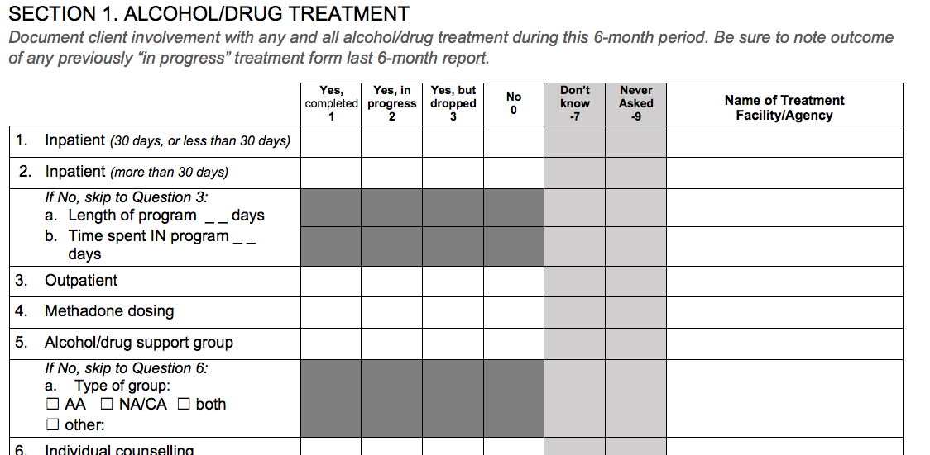
-- THE OLD –
Missing “Never asked” and other Inconsistencies

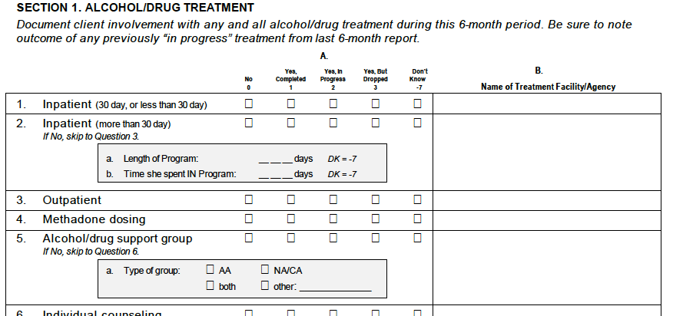

SAMPLE CHANGES
-- THE NEW --
“No or Don’t know” now separate choices,
Adds consistent choices
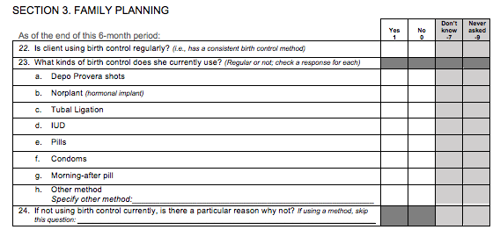
-- THE OLD --
“No or Don’t know” combined
